What is a landslide?
->
- A landslide is the downward and outward movement of
slope-forming materials (rock, soil, artificial fill, or a combination) under the direct influence of gravity. It occurs when the shear stress acting on a slope exceeds the shear strength of the slope material.
- Engineers formalize this threshold using the Factor of Safety (FoS) — the ratio of a slope's resisting shear strength to the driving shear stress. A slope is considered stable when FoS > 1; as this ratio approaches or drops below 1, the likelihood of failure increases sharply.

Types of Landslides:-
->
- Rockfall: Sudden, free-fall detachment of individual boulders or rock blocks from steep vertical cliffs, governed by fracture planes and freeze-thaw weathering.
- Mudslide: Rapid surging of fine-grained soil and water mixture with over 50% silt/clay content, moving like a viscous fluid along defined channels.
- Debris Flow: High-velocity, turbulent mixture of water, saturated loose soil, gravel, boulders, and organic debris capable of destroying infrastructure along drainage paths.
- Rockslide: Rapid downslope movement of large rock masses sliding along planar structural discontinuities (bedding planes, joints, or faults).
- Rotational Slides: Downward and outward movement along a concave-upward, curved failure plane, causing a backward tilt of the displaced block.

- Translational Slides: Mass movement along a roughly planar, predisposed geological surface (bedding/foliation boundary) parallel to the slope surface.

Major Causes & Factor Categorization:-
->

Natural Factors:-
  - Intense & Prolonged Rainfall :Short-burst intensity: High rainfall in 1–2 hours causes rapid surface runoff and triggers shallow mudslides or debris flows.
Prolonged duration: Moderate rain over 5–15 days slowly seeps deep underground, saturating deep soil layers and triggering massive rotational or translational slides.
  - Seismic Activity & Earthquakes: Ground shaking creates dynamic stress waves. This fractures internal rock joints and causes liquefaction—where loose, water-saturated sand or silt temporarily behaves like a liquid.
  - River Toe Erosion: Mountain rivers cut deeper and wider along their banks. Over time, the rushing water scoops away the natural "foot" or base (toe) of the mountain, leaving the slope above it completely unsupported.
  - Weathering & Geological Weakness: Natural freeze-thaw cycles, chemical decomposition from acidic rainwater, and alternating hot/cold days fracture and crumble hard rock into loose debris over time.

Human-Induced Factors:-
  - Unscientific Hill-Cutting & Road Construction: To build or widen highways (like mountain corridors), heavy machinery shears away the bottom of the slope vertically without constructing retaining walls or terraced benches. Removing that natural supporting foundation lets gravity take over.
  - Deforestation & Vegetation Removal: Tree roots act like natural biological rebar, binding loose soil particles together. Deforestation removes this root network and eliminates foliage that would otherwise intercept and slow down driving rain.
  - Shifting Cultivation: Common across northeastern states: patches of forest on steep hill slopes are slashed and burned for short-term agriculture. When heavy monsoon rains hit these bare, exposed topsoils, surface erosion and shallow slides surge.
  - Blocked & Unplanned Drainage: When towns, settlements, or roads are built without proper drainage channels, wastewater and storm runoff get dumped straight into the hillside soil, accelerating deep water percolation and slope destabilization.
  - Blasting & Overloading: Vibrations from dynamite blasting during quarrying or tunnel construction fracture adjacent rock formations. Concurrently, constructing multi-story concrete buildings on top of steep slopes adds immense downward weight (surcharge load).

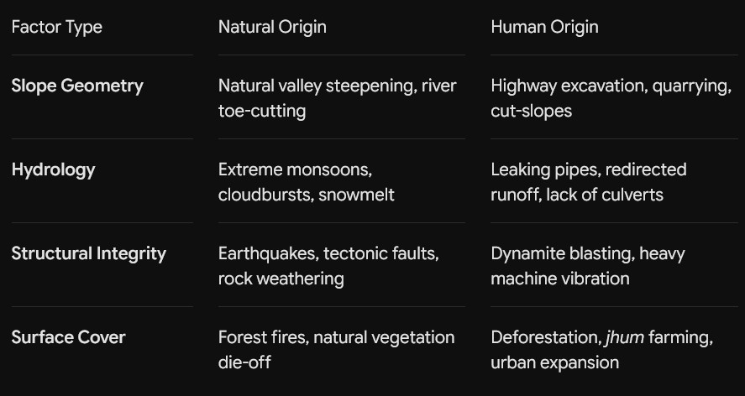

Relationships Between:-
->
- Rainfall: Driving dynamic trigger. High short-term intensity leads to rapid runoff and debris flows; prolonged continuous rain drives deep percolation, saturation, and large-scale deep-seated slides.
- Soil Moisture: Directly raises pore water pressure, reducing effective stress to zero, eliminating soil shear resistance.
- Slope: Steeper inclinations amplify the gravitational driving vector.
- Elevation: Determines rainfall microclimates (orographic precipitation patterns), thermal weathering rates, and
freeze-thaw cycles.
- Geology & Lithology: Young, folded, highly weathered sedimentary rocks (shale, phyllite, sandstone) fail significantly faster than crystalline igneous rock.
- Vegetation: Root networks provide mechanical soil cohesion, and foliage facilitates evapotranspiration to lower moisture saturation.

- Earthquakes: Ground acceleration introduces sudden lateral shear stress cycles and ruptures cohesive internal rock bonds.

Landslide-Prone Regions & Historical landslides in India/Northeast India:-
->

Vulnerable Zones in India:
North Eastern Region (NER): Assam, Meghalaya, Sikkim, Manipur, Mizoram, Nagaland, Arunachal Pradesh, Tripura (Highest vulnerability due to Seismic Zones V/IV and extreme monsoon precipitation).
Northwestern Himalayas: Jammu & Kashmir, Himachal Pradesh, Uttarakhand.

Landslide-Prone Regions of India & Historical Landslides:
- Landslide-Prone Regions of India
According to the Geological Survey of India (GSI), roughly 12.6% of India's landmass (~430,000 km²) is prone to landslide hazards, spread mainly across the Himalayan belt and the Western Ghats.

Northeastern Region (NER) & Eastern Himalayas:
  - States: Assam, Meghalaya, Sikkim, Arunachal Pradesh, Nagaland, Manipur, Mizoram, Tripura, and parts of West Bengal (Darjeeling/Kalimpong).
  - Vulnerability Profile: Highest risk density in the country. Driven by tectonic collision, active faulting, fragile young sedimentary rocks, and world-record monsoon rainfall.

Northwestern Himalayas:
  - States/UTs: Uttarakhand, Himachal Pradesh, Jammu & Kashmir, Ladakh.
  - Vulnerability Profile: Very high relief, steep rocky slopes, high seismicity, rapid river incision, flash floods, and cloudburst triggers.

Key Historical Landslides in Northeast India:
  - Tupul Railway Yard Disaster, Manipur (June 2022):
    - Mechanism: A catastrophic debris flow/rockslide along the Jiribam–Imphal railway construction site.
    - Triggers: Relentless heavy rainfall over multiple days combined with massive toe-cutting for platform excavation.
    - Impact: 61 people died (including Territorial Army personnel); debris dammed the Ijai River, creating a high-risk artificial lake.

Dima Hasao Railway Link Washout, Assam (May 2022):
    - Mechanism: Multiple translational slides, mudflows, and track bed washouts across the Lumding–Badarpur mountain rail corridor.
    - Triggers: Continuous torrential pre-monsoon downpours over soft, weathered shale slopes stripped of vegetative cover.
    - Impact: 3 deaths, ~85 km of track damaged at 61+ breach points, ₹180 crore sanctioned for restoration. Rail connectivity between the Barak Valley, Tripura, Mizoram, and the rest of India was completely severed for approximately two months.

Guwahati Urban Hill Failures, Assam :
    - Mechanism: Shallow earth slides and mudflows across urban hills (e.g., Narakasur, Kharguli, and Nabagraha hills).

    - Triggers: Dense, unplanned hill settlements, vertical toe-slashing for residential construction, and lack of stormwater culverts.

Sikkim Flash Flood & Slope Failure Cascades (Teesta Basin, October 2023):
    - Mechanism: A large landslide into South Lhonak Lake triggered a Glacial Lake Outburst Flood (GLOF); the resulting flood surge eroded the Teesta River gorge, causing 45 secondary landslides along NH-10 and damaging hydropower infrastructure.
    - Impact: Death toll estimates range from 24 to 77 across different assessments (varying by cutoff date and
missing-persons reclassification); the GLOF destroyed 13 bridges and the Teesta-III hydropower dam, and directly affected over 60,000 people across four Sikkim districts.

Northeast landslides are unique because they are multi-hazard cascades: (Team Synthesis)
- In the Northwest Himalayas, rockfalls and translational slides predominate on drier, less-weathered rock slopes (schist, quartzite, gneiss), where failures are more strongly controlled by joint patterns and rock structure than by soil saturation.
- In the NER, slopes are dominated by deeply weathered, clay-rich soils formed on sedimentary Tertiary Belt rock, saturated by heavy monsoon rainfall. Failures rapidly transition from small slides into high-velocity channelized debris flows that block river valleys and take out transport corridors.

Existing Susceptibility Mapping Systems:
- Geological Survey of India (GSI) — National Landslide Susceptibility Mapping (NLSM)
- Scale: Macro-scale mapping at 1:50,000 covering the entire
~4.3 lakh sq. km (≈430,000 km²) of landslide-prone terrain in India, across 19 states and Union Territories, including the Himalayan region, the Tertiary Belt of Northeast India, and the Western Ghats.
- Methodology: A weighted-overlay scoring method combined with the Analytic Hierarchy Process (AHP), using causative factor layers such as slope, lithology, rainfall, land use, and drainage.
- What it does: Classifies terrain into three susceptibility zones — High, Moderate, and Low. (Note: some independent academic studies use a finer 5-class breakdown, but GSI's own official classification uses three classes.)
- Limitation: It is purely static. It tells you where a landslide is structurally prone to happen, but not when. It cannot ingest live rainfall or soil saturation data to tell an administrator whether a slope will fail this afternoon.

ISRO / NRSC — Landslide Atlas of India (Released 2023)
- Coverage: Geospatial landslide inventory of ~80,000 historical landslides across 17 states and 2 Union Territories between 1998 and 2022.
- Key Finding for NER: Mizoram recorded the highest number of historical landslides in India (12,385, of which 8,926 occurred in 2017 alone), with Tripura (8,070) and Arunachal Pradesh (7,689) also ranking in the national top five. (For context: Uttarakhand ranks #2 nationally with 11,219 — Mizoram is the single
worst-affected state, but NER isn't the top-ranked region overall.)
- Portal: Hosted on ISRO Bhuvan.

- Limitation: It is a historical inventory and damage atlas, primarily mapping post-disaster scars using
IRS/Cartosat/Sentinel imagery. It does not function as an operational real-time early warning system.

Deliverable: Variables the System Should Monitor
->

Variable | Type | Why It Matters | Possible Data Source
Rainfall Intensity & Cumulative Rainfall | Dynami c | Primary trigger in NER; short-burst intensity drives shallow debris flows, antecedent cumulative rainfall drives deep-seated saturation failures | IMD, NASA GPM  (satellite), local automatic rain gauges
Soil Moisture | Dynami c | Acts as the "memory" of recent rainfall; raises pore-water pressure, directly reducing shear resistance | Satellite (SMAP), IoT  soil-moisture sensors
Slope Gradient | Static | Steeper slopes amplify the gravitational driving force; critical-angle | DEM (SRTM,  Cartosat)

thresholds vary by rock/soil type

Elevation & Aspect | Static | Correlates with orographic rainfall patterns, freeze-thaw weathering rate, and vegetation zonation | DEM
Geology & Lithology | Static | Determines shear strength and permeability; young, weathered sedimentary rock (NER's Tertiary Belt) fails faster than crystalline rock | GSI geological maps, NLSM susceptibility layers
Vegetation  Cover (NDVI) | Semi-dy namic | Root networks provide  mechanical soil cohesion; canopy loss increases both erosion and infiltration rate | Satellite imagery (Sentinel-2, Landsat)
Seismic Activity | Dynami c  (event-b ased) | Independent trigger mechanism via ground acceleration and liquefaction, distinct from rainfall-driven failures | National seismic monitoring network (NCS)

River/Toe Erosion | Semi-dy namic | Undercutting removes slope support at the base; a leading indicator near river channels and road cuts | River gauge data, periodic satellite  change-detecti on
Land-Use Change / Deforestation | Semi-dy namic | Human-induced risk multiplier; loss of root cohesion and rise in runoff velocity | Satellite land-cover time series
Anthropogen ic Slope Modification | Semi-dy namic | Unscientific hill-cutting, quarrying/blasting, and unplanned drainage directly destabilize otherwise stable slopes | Field survey, construction permit records, drone imagery
Historical Landslide Inventory | Static referenc e | Ground truth for model training/validation | GSI/NRSC  Landslide Atlas of India

